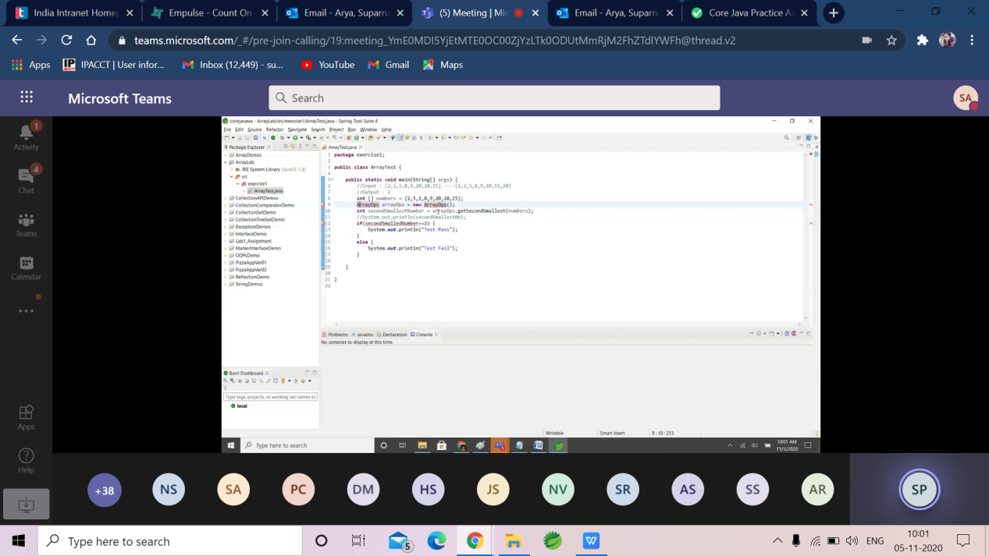

[10:27 AM] Srivastava, Vaishali

|  |  |
| --- | --- |
| Exception Handling | **3** |
| Collection and Generics | **4** |
| Multithreading | **2** |
| Concurrency | **1** |
| Lambda Expression | **2** |
| Stream API | **1** |
| Junit | **2** |
| SQL | **2** |
| JDBC | **3** |
| **Core Java** | **20** |

​

[10:28 AM] Srivastava, Vaishali

Part-2

​

[10:29 AM] Srivastava, Vaishali

|  |  |
| --- | --- |
| Data Types and Operators | **2** |
| Control Statements and Arrays | **2** |
| Classes and Objects | **2** |
| Constructors | **3** |
| String Handling | **3** |
| Static Modifier | **2** |
| Inheritance and Polymorphism | **3** |
| Abstract class and Interface | **3** |
| **Core Java** | **20** |

Part-1